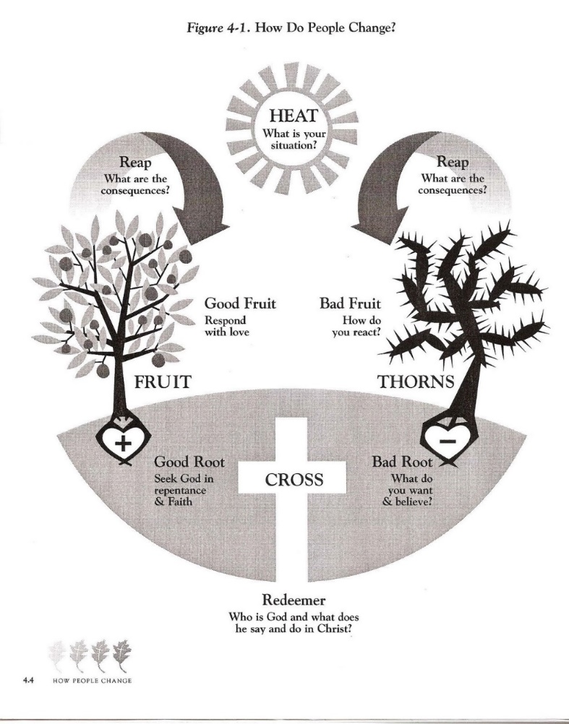
Unbelief. At the heart of every sin is unbelief—unbelief that what God has said is both true and in our best interest (“Did God really say?” ^{Gen. 3:1} It is imperative, therefore, that we put sin to death as we are transformed into the image of our Savior, Jesus Christ. ^{Rom 8:12-14; 28-30} Sin originates in the heart and then manifests itself outwardly. ^{Matt 12:35} Therefore, we must aim at the sin at the heart level for true transformation. As an illustration, if you are shark hunting, it will do you little good to simply aim at what you can see on the surface (the fin). If you are going to kill the shark, you must aim at that which is beneath the surface. Similarly, when we fight sin, we must not aim simply aim at changing our behavior or the way that sin visible manifests itself on the surface. We must aim at that which is beneath the surface in the heart.
Heart. Scripture defines the heart as the “wellspring of life.” ^{Prov 4:23} It speaks of the heart in three interrelated ways: (1) cognition (what am I thinking); (2) affection (what am I desiring, feeling, what are my emotions); and (3) volition (what am I choosing, acting on). What we treasure in our heart drives every decision we make. ^{Matt 12:35} The diagram to to the right illustrates that how we react or respond to the heat of our circumstances/temptation will reap either thorns or fruit based on where our hearts are rooted. This exercise is not aimed at changing behavior but allowing Christ to transform our hearts. ^{Rom 12:1-2} We want to shine light in areas of our hearts that still have “bats in the cave.” By bringing one area of besetting sin under the microscope, we can identify its root over the course of a few weeks and put it to death as we evaluate it under the light of Scripture. Page two is a handout with prompts for journaling once each week through our particular sin.
Besetting sins. A besetting sin could be a number of options: attitude (pride, competitive, arrogance, selfish, bitterness, anxiety, driving habits); words (falsehood, slander, gossip, idle talk); sexual immorality (pornography, fornication, adultery, homosexuality, lust); work (work-aholic, laziness, stealing time); relational (unresolved anger, bitterness, unforgiveness); time (technology, video games, social media, etc.); money (possessions, comforts, entertainment, quick fix shopping, etc.); substance (alcohol, drugs, pain meds, etc.).
Freedom. To be free in Christ is to be free like Christ was free. Those who are in Christ have been freed from the power of sin, are being freed from sin’s presence, and will one day be freed from sin completely (Rom 8:30; Rev 5:9). They have been set free from their former slavery to the flesh to love God and love others in a way that they were not free to do before. Romans 6 tells us that we never have to sin! However, temptation will present itself to us as inescapable, but we must remember that it is lying! Scripture is clear: we never have to give in … ever! When our nature changed, we were freed from what once held us in bondage.
Using this worksheet. Print this form and commit to spending 20-30 minutes filling it out once a week. The short amount of time that you devote to this exercise will play massive dividends. Take your sin seriously. In the words of John Owen, be serious about “killing sin or sin will be killing you.”

Sin. My specific sin struggle: . . . . . . . . . . . . . . . . . . . . . . .
circumstance (i.e., “heat”). ¹ Where/when was I was confronted with this particular sin/temptation this week? ² What was I thinking, feeling, and choosing in the midst of that situation? ³ What did I not have that I wanted? ⁴ What did I perceive as most important in that moment?
. . . . . . . . . . . . . . . . . . . . . . . . . . . . . . . . . . . . . . . . . . . . . . . . . . . . . . . . . . . . . . . . . . . . . . . . . . . . . . . . . . . . . . . . . . . . . . . . . . . . . . . . . . . . . . . . . . . . . . . . . . . .
Others. ¹ What was/were the most significant voice(s) that I heard in that situation (e.g. could be a voice from the past, pressure from a parent, spouse, boss, etc.)? ² What influence did that voice have on how I reacted? ³ How am I responding to my significant relationships, either faithfully or sinfully? (Lashing out (aggressive) or giving in (passive)?)
. . . . . . . . . . . . . . . . . . . . . . . . . . . . . . . . . . . . . . . . . . . . . . . . . . . . . . . . . . . . . . . . . . . . . . . . . . . . . . . . . . . . . . . . . . . . . . . . . . . . . . . . . . . . . . . . . . . . . . . . . . . .
IDENTITY. ¹ What is my identity actually in? ² What elements of my constructed identity align with God’s view? ³ What do not? ⁴ What is my posture towards God and towards others?
. . . . . . . . . . . . . . . . . . . . . . . . . . . . . . . . . . . . . . . . . . . . . . . . . . . . . . . . . . . . . . . . . . . . . . . . . . . . . . . . . . . . . . . . . . . . . . . . . . . . . . . . . . . . . . . . . . . . . . . . . . . .
God. ¹ How do I see God as being involved in my story? ² What is accurate about my view of God? ³ What is inaccurate?
. . . . . . . . . . . . . . . . . . . . . . . . . . . . . . . . . . . . . . . . . . . . . . . . . . . . . . . . . . . . . . . . . . . . . . . . . . . . . . . . . . . . . . . . . . . . . . . . . . . . . . . . . . . . . . . . . . . . . . . . . . . .
Bible. ¹ What Bible passages, themes, promises, or principles are applicable to my situation? ² How does this relate to Jesus Christ and the gospel?
. . . . . . . . . . . . . . . . . . . . . . . . . . . . . . . . . . . . . . . . . . . . . . . . . . . . . . . . . . . . . . . . . . . . . . . . . . . . . . . . . . . . . . . . . . . . . . . . . . . . . . . . . . . . . . . . . . . . . . . . . . . .
Prayer. Write out a specific prayer asking God for help regarding what you have discerned above.
. . . . . . . . . . . . . . . . . . . . . . . . . . . . . . . . . . . . . . . . . . . . . . . . . . . . . . . . . . . . . . . . . . . . . . . . . . . . . . . . . . . . . . . . . . . . . . . . . . . . . . . . . . . . . . . . . . . . . . . . . . . .

Timothy S. Lane and Paul David Tripp, How People Change, 2nd ed (Greensboro, N.C: New Growth Press, 2008).

