Accountability Wheel

*All of Life to the Glory of God*

God designed us for abundant life according to His good design. John 10:10 In the words of John Piper, “God is most glorified in us when we are most satisfied in Him.” This accountability wheelis a tool to help us grow in Christlikeness. To fill this out, simply trace the circle where you are within each category on a scale of 0 (struggling) to 10 (flourishing). On the back of this page, you will find references to Scripture that help to define each of these categories biblically.

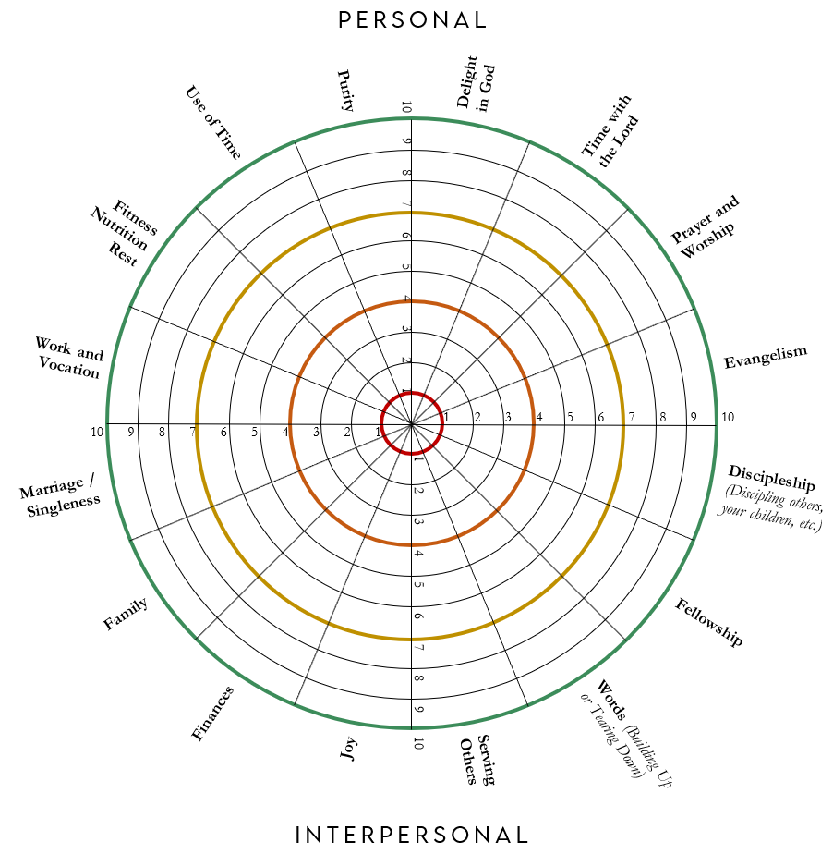**Questions**

* + - 1. This month, I want to grow in: _______________________

______________________________________________

* + - 1. What does this look like in practical terms?

________________________________________________________________________________________________________________________

* + - 1. What are my two highest areas (on the wheel)?

____________________ __________________

* + - 1. What are my two lowest areas (on the wheel)? What practical steps can I take to grow in these two areas?

____________________ ____________________

____________________ ____________________

____________________ ____________________

____________________ ____________________

* + - 1. *For discussion only.* Have I compromised God’s good design for marriage in any way (e.g., masturbation, pornography, inappropriate thoughts, desires, fantasies, etc.)? Have I interacted with anyone in a way that could be viewed as compromising? Is there any area where my interactions have lacked honesty or integrity?
      2. Where am I struggling to trust the Lord (e.g., anger, anxiety, bitterness, covetousness/idolatry, discouragement, impatience, joylessness, laziness, lust, misplaced shame, perfectionism, pride, selfishness, etc.)?

__________________________________________________________________________________________

* + - 1. What is my single greatest prayer need right now (be as specific and succinct as possible)?

__________________________________________________________________________________________

**Bandwidth** *Shade in the box where you feel like you’ve been on average.*

**Bible References for Each Area**

### Delight in God: Psalm 37:4-5; Matthew 13:44; Luke 6:38; John 15:1-11

1. **Time with the Lord**:Psalm Mark 1:35-37; Luke 5:16; Romans 1; 12:1-2
2. **Prayer and Worship**: Matthew 6:5–8; Philippians 4:6–7; Psalm 95:1-6; John 4:24; Romans 12:1-2; Colossians 3:16-17; Hebrews 13:15
3. **Evangelism**: Jeremiah 20:9; Matthew 28:18-20; John 15:16–17; 1 Peter 2:9; Romans 10:14–17; 2 Corinthians 5:18-21
4. **Discipleship**: Matthew 28:16–20; Luke 9:23–24; Colossians 1:28–29; 2 Timothy 2:1–2
5. **Fellowship:** John 13:34–35; Acts 2:42-47; Hebrews 10:24-25
6. **Words**: Luke 6:45; Ephesians 4:15, 29; 1 Thessalonians 5:11; James 3:5-12
7. **Serving Others**: Mark 10:45; Philippians 2:3-11
8. **Purity**: Matthew 5:8, 27; 1 Thessalonians 4:3-5; 1 Timothy 4:12; Romans 13:14
9. **Use of Time**: Psalm 90:12; Ephesians 6:15-16 | **Rest**: Psalm 23:1-2; Psalm 62:1; Psalm 129; Matthew 11:28-30; Hebrews 4:9-10
10. **Fitness and Nutrition**: Romans 12:1-2; 1 Timothy 4:8
11. **Work/Vocation**: Genesis 2:15; Psalm 90:17; Colossians 3:23-24; 2 Timothy 2:6
12. **Marriage**: 1 Corinthians 13; Ephesians 5:22-27; Colossians 3:18; 1 Peter 3:7; Hebrews 13:4
13. **Family**: Proverbs 22:6; Psalm 128:3; Psalm 127:4-5; Deuteronomy 6:4-9; Ephesians 3:14-15
14. **Finances**: Proverbs 3:9–10; Matthew 6:24–25; Luke 16:9; 1 Timothy 6:7–10; Luke 12:19–21
15. **Joy**: Ecclesiastes 2:24; Psalm 16:11; Nehemiah 8:10; John 10:10; 15:10–11; Romans 15:13; Galatians 5:22–23